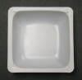
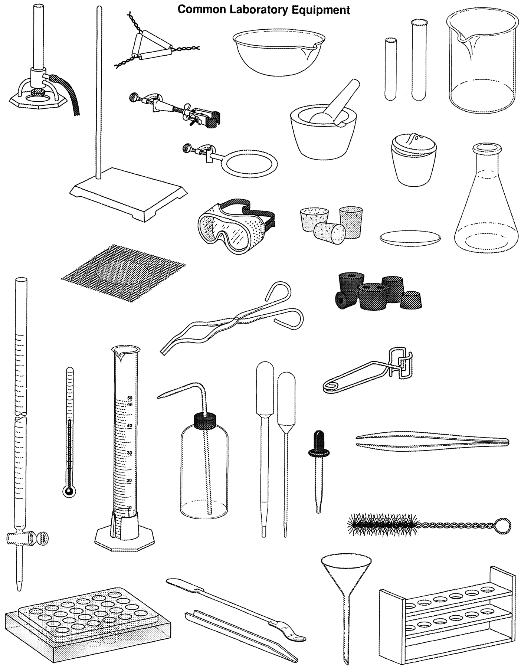
32
26
25
19
18
17
12
11
20
31
21
15
13
30
29
27
28
24
23
22
16
14
10000
9
8
7
6
5
3
4
2
1

1.

2.

3.

4.

5.

6.

7.

8.

9.

10.

11.

12.

13.

14.

15.

16.

17.

18.

19.

20.

21.

22.

23.

24.

25.

26.

27.

28.

29.

30.

31.

32.

